1. SSS (Social Security System)

* Table and Calculation

<https://www.sss.gov.ph/sss/DownloadContent?fileName=2021-CONTRIBUTION-SCHEDULE.pdf>

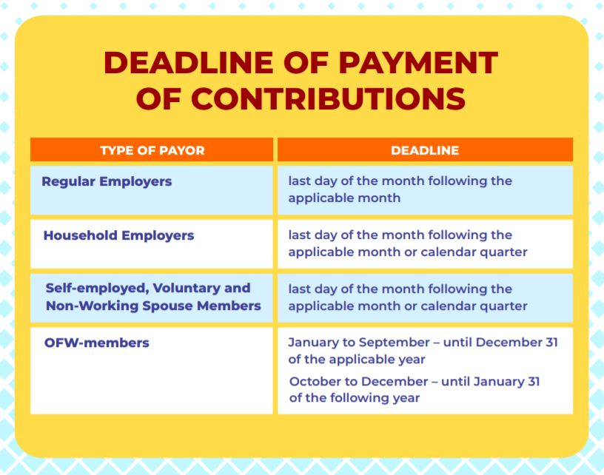

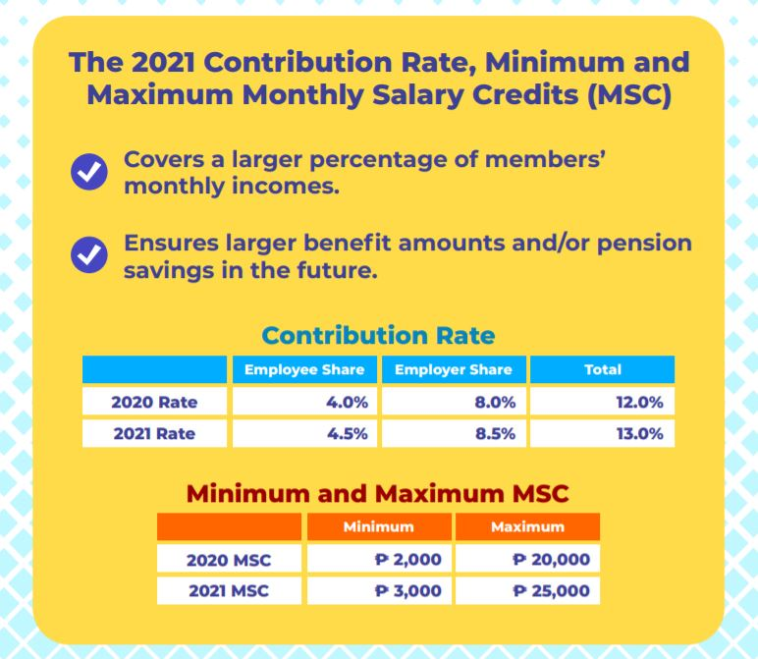

* https://mpca.com.ph/new-sss-contribution-table/

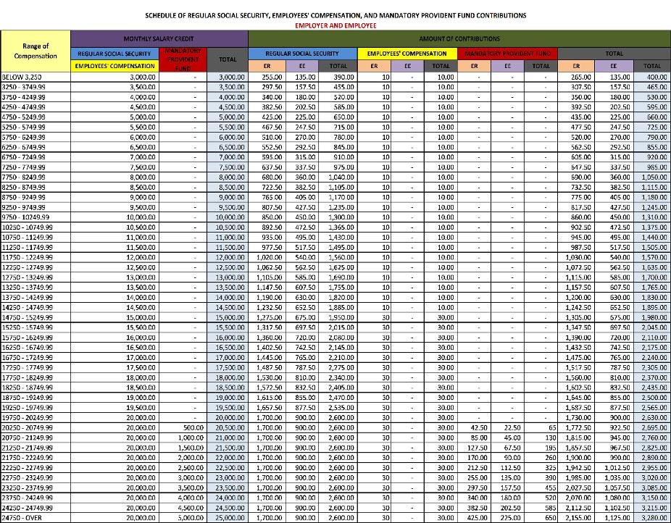

2. PhilHealth

* <https://www.grantthornton.com.ph/newsroom/technical-alerts/outsourcing-alerts/2020/new-phic-and-sss-contributions-table-effective-january-2021/>
* https://filipiknow.net/philhealth-contribution/#:~:text=Since%20the%202021%20premium%20rate,annual%20contributions%20of%20Php%2010%2C092.06.

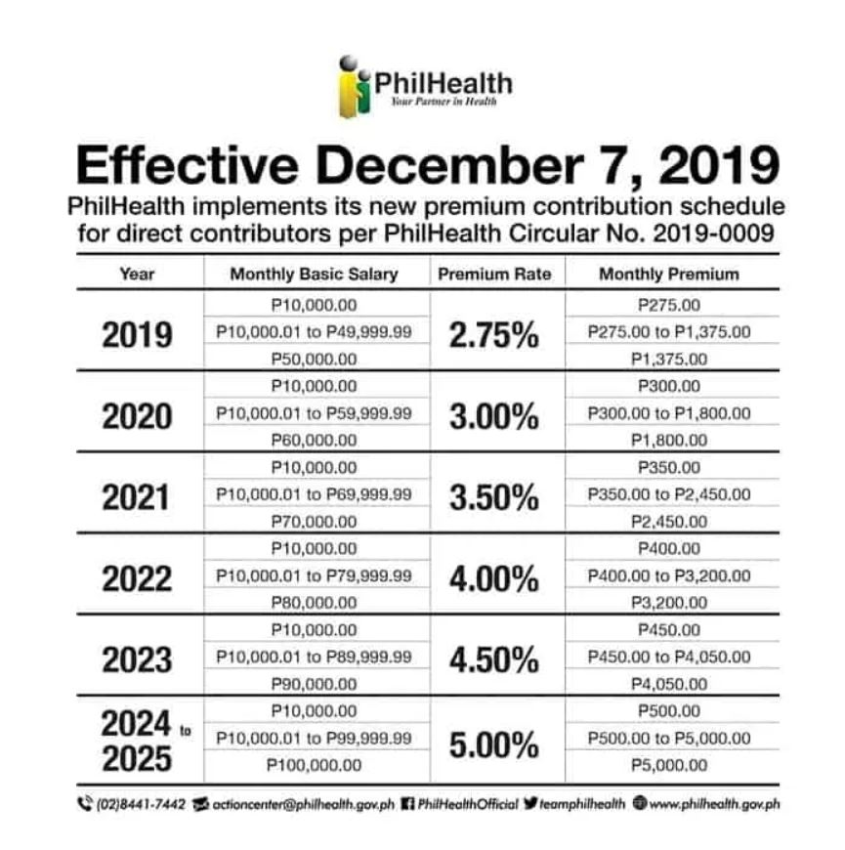

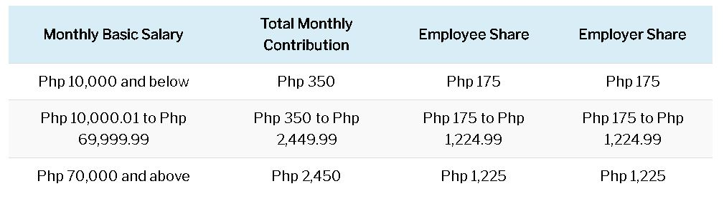

1. Tax Calculation

* <https://taxcalculatorphilippines.com/> (yung ibang steps is nandito na link)

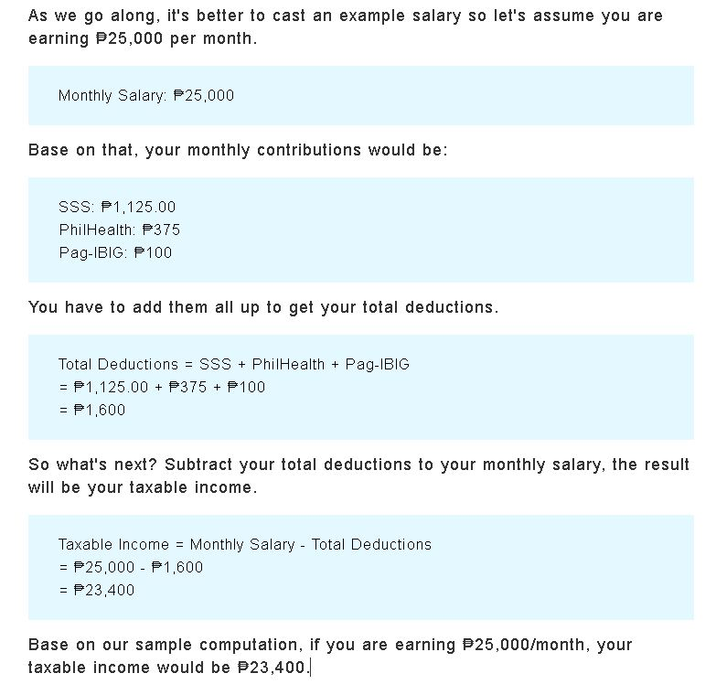

https://filipiknow.net/pag-ibig-contribution-table/

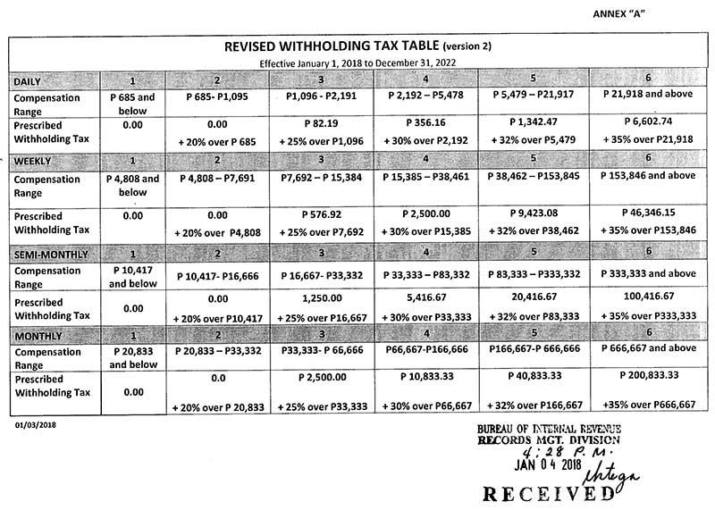

1. 13th Month Pay

* <https://bwc.dole.gov.ph/faqs-on-13th-month-pay>
* <https://www.imoney.ph/articles/13-month-pay-computation/>

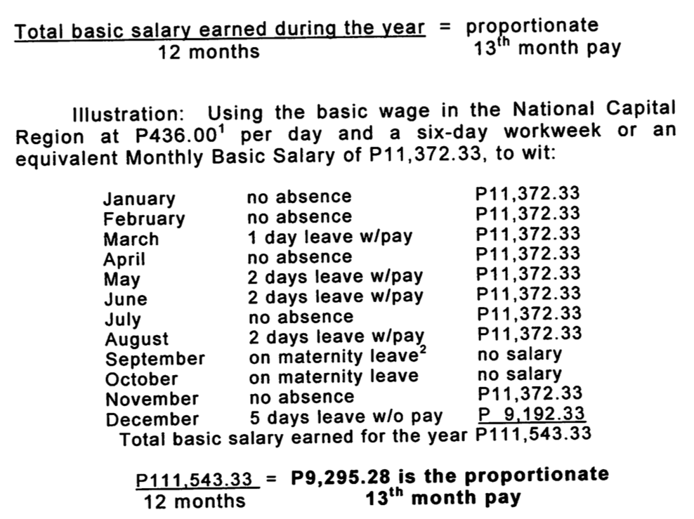



1. Premium Pay and Overtime Pay

- <https://kcrecruitment.com/hr-consulting/labor-and-employment/salary/>

- <https://kittelsoncarpo.com/wp-content/uploads/2016/04/COMPLETE-GUIDE-INFOGRAPH_2-min.png>

- https://ph.news.yahoo.com/compute-holiday-pay-020023689.html

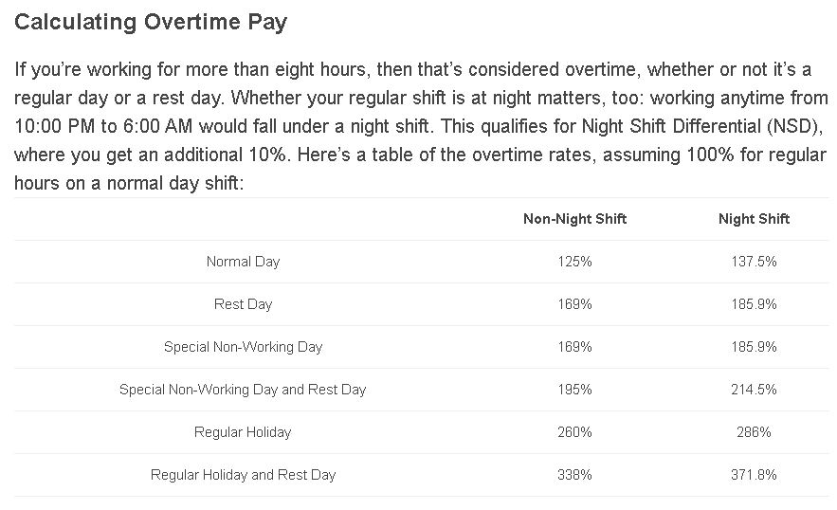

* Regular Holiday

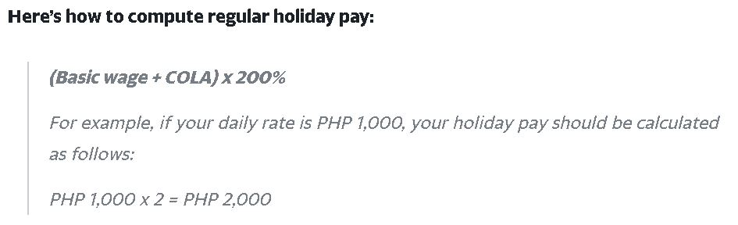

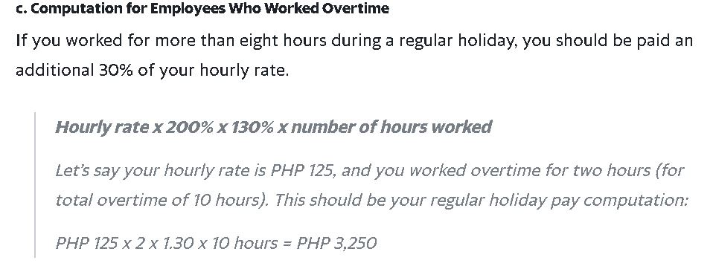

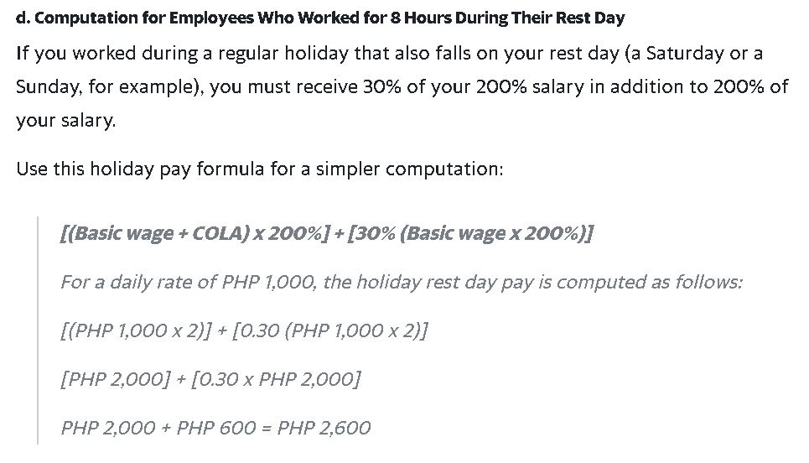

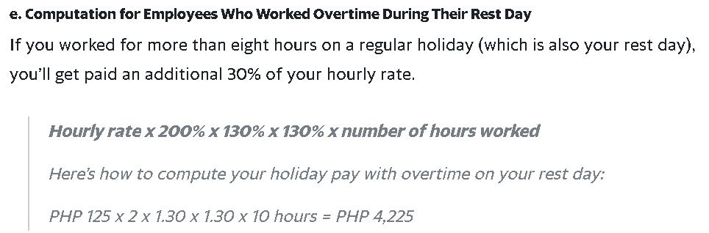

* Special Holiday Pay

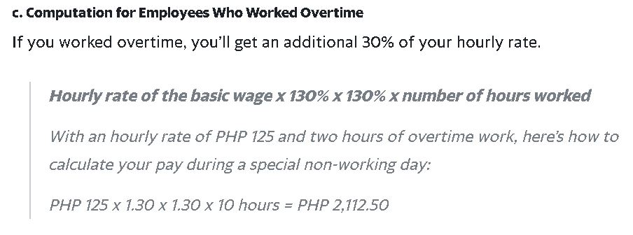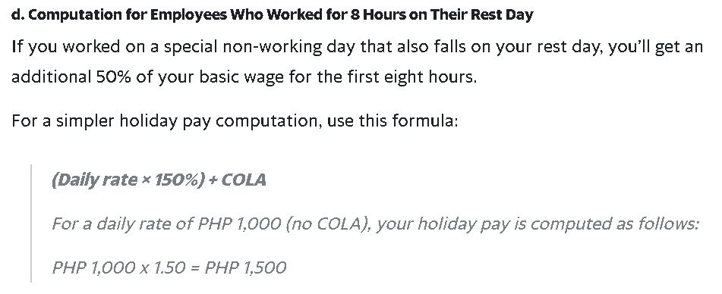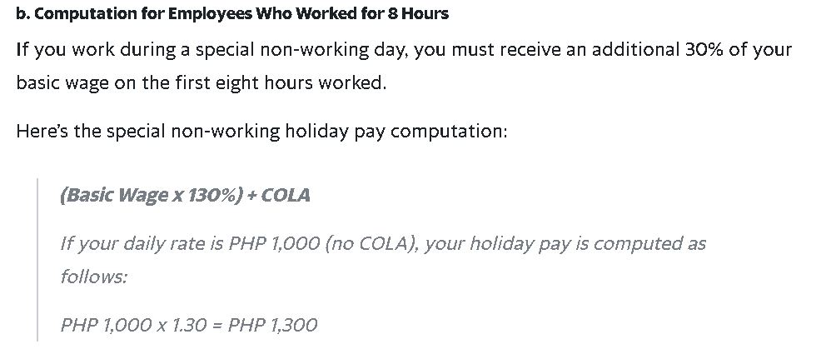

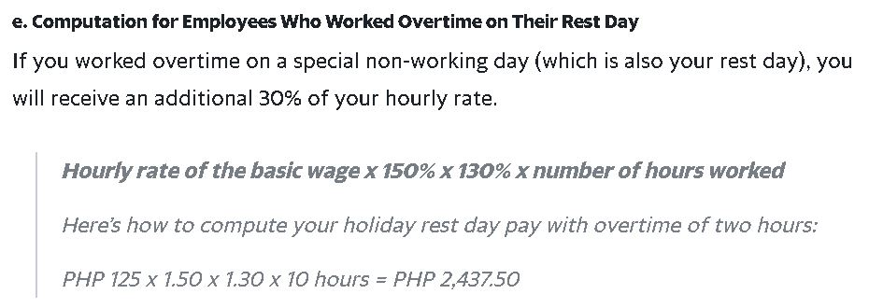

* LEAVE TYPES BENEFITS

https://www.onsemi.com/site/pdf/Benefits-Summary-Philippines.pdf?fbclid=IwAR3sKSTHiBIqPB0ynjHaDDKMisk7B-ZflnlgYcUbXZeqJT9Kf1RQS22xig8